**Yarning Circle @ NSC**

‘This year’s theme encourages all of us to champion institutional, structural, collaborative and cooperative change in Aboriginal and Torres Strait Islander communities over generations’. - National Indigenous Australians Agency.

In Term 1, some of our junior Koorie students participated in Aspirations Day at GMHBA Stadium in Geelong. We met up with Aunty May and Aunty Denise, Uncle Richard, Aunty Zeta, Aunty Megan, our KESO Nicholas and a highlight was rubbing shoulders with icon Isaiah Firebrace.

A day filled with lots of activity, old friends, new friends, games, goal setting, hip-hop dancing, making some art with our KESO Nicholas, had lunch and got a show bag full of goodies!

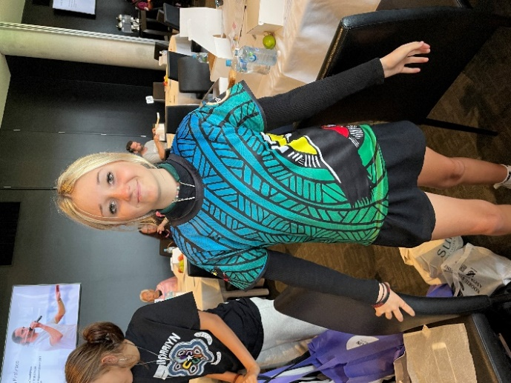

To help build our connections with Wathaurong Co-operative, we will be welcoming another NSC alumnus, Mick Ryan to share his story this Thursday 5th May, 2022 during Homegroup @10.20am and then we will share some morning tea. Mick currently works in the area of health promotions and is a musician.

We look forward to welcoming more community members, family, friends and industry leaders to Newcomb Secondary College to help build aspiration, connection, understanding and resilience amongst our Koorie students.

Keep reaching for the stars! Ms Amanda P, Ms Amanda D. & Mrs Honeywell