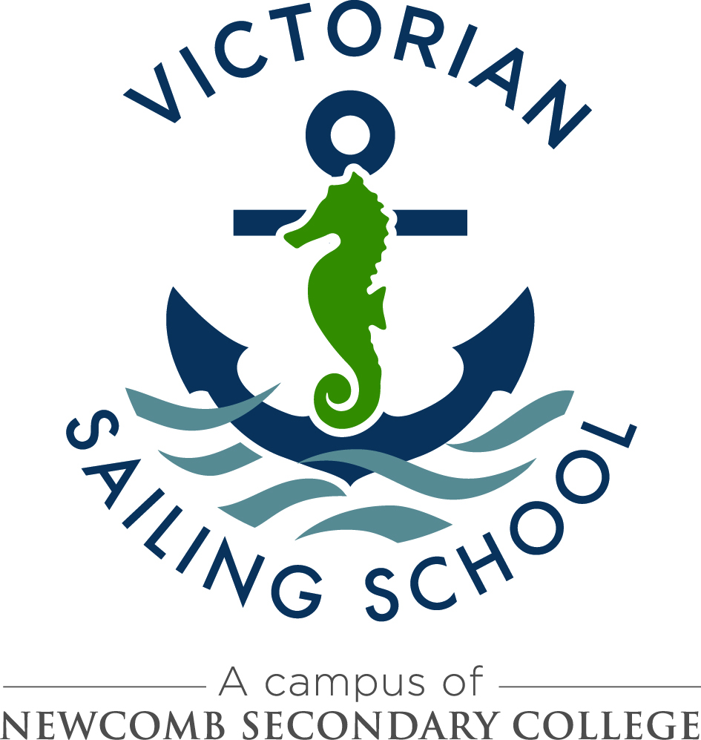

2021 Bookings – Key Dates

Friday 19th June – key dates, posted online @
http://www.newcombsc.vic.edu.au/sailing_school/index

Friday 19th June – ‘Expression of Interest – 2021 and 2021 Booking Proforma’, posted online

Tuesday 21st July – ‘Expression of Interest – 2021 and 2021 Booking Proforma’, emailed to all 2020 Visiting Teachers / School Principals

Wednesday 22nd July - ‘Expression of Interest – 2021 and 2021 Booking Proforma’, emailed to ALL Principals state wide

Monday 25th July – expressions of interest for 2021 bookings open (by email)

Friday 11th September – expressions of interest close – note: may close earlier if demand exceeds availability

Friday 9th October – First round 2021 offer forwarded by email, bookings to be confirmed after offer has been accepted via edumail

Monday 9th November – Second round 2021 offer forwarded

Monday 2nd November to Friday 6th November– booking confirmation letters sent to all 2021 visiting teachers / Principals

