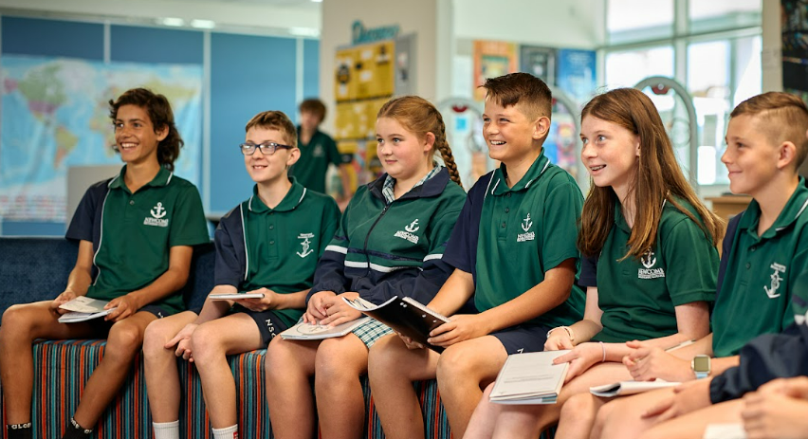

2024

Year 7 and 8

STUDENT

HANDBOOK

**GENERAL** **INFORMATION**

Key Contact Staff 1

Student Support 1

**PARENT PAYMENT INFORMATION**

Financial Assistance **2**

Subject Costs 3

**YEAR 7 COURSE OUTLINES**

Year 7 Curriculum Overview 5

Year 7 English 6

**CONTENTS**

Year 7 Humanities ……………………………………………………………………………………………….7

Year 7 Mathematics 8

Year 7 Science 9

Year 7 Physical, Health and Sports Education 10

Year 7 LOTE – Indonesian 11

Year 7 The Arts 12

Visual Arts ………………………………………………………………………………………………….. 12

Instrumental Music 13

Music 14

Year 7 Technology 15

Food 15

Metal 16

GROW (Getting Ready for the Outside World) …..………………………………………………17

**YEAR 8 COURSE OUTLINES**

Year 8 Curriculum Overview 19

Year 8 English 20

Year 8 Humanities ……………………………………………………………………………………………..21

Year 8 Mathematics 22

Year 8 Science 23

Year 8 Physical, Health and Sport Education 24

Year 8 LOTE (Indonesian) 25

Year 8 The Arts 26

Visual Arts 27

Instrumental Music 28

Year 8 Technology

Fabric 29

Wood 30

GROW (Getting Ready for the Outside World) …..………………………………………………31

GENERAL INFORMATION

**Key Contact Staff 2024**

**Principal:**

Scott McLeod

**Assistant Principals:**

Kel Montano – Senior Years

James Murphy – Junior Years

**Careers Advisors:**

Megan Fell

Joanne Spence

**Year 7, 8 & 9 Team Leader:**

Eliza Hunt

**Learning Area Leaders:**

Arts Ben Davis

Technology Matt Amer

English Tracy Allinson

Health & PE Cam Goward

LOTE Sarah Stoneley

Mathematics Lisa Dyer

Science Phil Walker

Humanities Ryan Owens

GROW Chris George

**STUDENT SUPPORT**

* Teachers at Year 7 and 8 along with Team Leaders at these Year Levels will provide information about subject selection.
* Information nights and parent interviews are held to provide individual support.
* Subject teachers, Team Leaders and Careers Counsellors are all available. **Ask for help!**

PARENT PAYMENT Information

Schools provide students with free instruction to fulfil the standard Victorian curriculum and we want to assure you that all contributions are voluntary. Nevertheless, the ongoing support of our families ensures that our school continues to provide the best possible education and support for students.

There are three categories of Parent Payments:

1. **Curriculum Contributons:** Voluntary financial contributions for curriculum items and activities which the school deems necessary for students to learn the Curriculum.
2. **Other Contributions:** Voluntary financial contributions for non-curriculum items and activities that relate to the school’s functions and objectives. Newcomb Secondary College has a Building Fund and Library Fund which are both tax deductible contributions. The Building Fund helps support upgrades and maintenance of school infrastructure and the Library Fund supports book purchases and other equipment to help sustain the library as a valuable resource.
3. **Extra-Curricular items and Activities:** Items and activities that enhance or broaden the schooling experience of students and are above and beyond what the school provides for free to deliver the Curriculum. These are provided on a user-pays basis.

**Financial Assistance**

Families who would like assistance in paying voluntary fees and charges can arrange a payment plan by contacting the Business Manager, Tansy Young.

Any of the below options may be used to pay voluntary contributions.

 Payments can be made from the beginning of 2024 via the school’s Compass Portal.



Payment can be made directly to the College Office using cash, cheque or EFTPOS.



By contacting the College Office on 5248 1400 with your payment and card details.

When making a payment via BPAY please contact the office for your individual reference number and to inform them of what items you wish to make the contribution towards. Telephone 5248 1400 or email the details to: [newcomb.sc@education.vic.gov.au](mailto:newcomb.sc@education.vic.gov.au)

Centrepay can be used to arrange regular deductions from your Centrelink payment. Payments can be arranged individually through Centrelink at: <http://www.humanservices.gov.au/customer/service/Centrelink/centrepay> or the school can submit your application to Centrelink on your behalf. To apply families must hold an eligible concession card.

Please contact the school to inform them of what items you wish to make the contribution towards. Telephone or email the details to: [newcomb.sc@education.vic.gov.au](mailto:newcomb.sc@education.vic.gov.au)

Please enquire at the College Administration office if you would like to know more.

The following table is provided to assist families with the voluntary costs of subjects in 2024. **It is based on 2023 charges and is subject to change.** While the charges are voluntary, Newcomb Secondary College would like to invite families to make a financial contribution to support the school, using the following table as a guide for the costs.

|  |  |
| --- | --- |
| **Year 7 Subject Costs in 2024** | |
|  | **Amount** |
| Year 7 Student Organiser Diary | $14.00 |
| NSC Combination Lock | $10.00 |
| Arts Music – Sound Trap On-line Resource (per sem) | $8.00 |
| Mathematics – Maths Pathways On-line Resource (per year) | $65.00 |
| English – Renaissance and Reading Strategy On-line Resources (per year) | $18.00 |
| Science – Photocopying & printing of class workbooks (per year) | $15.00 |
| Food Technology – Food ingredients such as flour, eggs, sugar, etch (per sem) | $50.00 |
| Metal Technology – Supplies such as metal, rivets, paint and polish (per sem) | $50.00 |
| Visual Arts – Craft paper, paint and clay (per sem) | $35.00 |
| GROW – CURA On-line Resource (per year) | $20.00 |
| Printing/Photocopying of Worksheets and Learning Materials (per year) | $10.00 |
| *\*OPTIONAL Instrumental Music Program* | *$80.00 ($20 per term)* |
| *\*OPTIONAL Musical Instrument Hire* | *$80.00 ($20 per term)* |

|  |  |
| --- | --- |
| **Year 8 Subject Costs in 2024** | |
|  | **Amount** |
| Year 8 Student Organiser Diary | $14.00 |
| NSC Combination Lock (if not retained from previous year) | $10.00 |
| The Arts:  Art – Craft paper, paints, clay and various art supplies *(Term Subject)*  VCD – Paper and ink *(Term Subject)*  Media – Paper, card, paints and modelling materials *(Term Subject)*  Music – Soundtrap and Ableton *(Term Subject)* | $30.00  $15.00  $15.00  $8.00 |
| English – Renaissance and Reading Strategy On-line Resources (per year) | $18.00 |
| Mathematics – Maths Pathways On-line Resource (per year) | $65.00 |
| Science – Photocopying and printing of class workbook (per year) | $15.00 |
| GROW – Kits, craft paper, glue, etc | $20.00 |
| Technology – Wood *(Semester Subject)* | $50.00 |
| Technology – Fabric *(Semester Subject)* | $20.00 |
| Year 8 Printing and Photocopying of Worksheets and Learning Materials | $10.00 |
| *\*OPTIONAL Instrumental Music Program* | *$80.00 ($20 per term)* |
| *\*OPTIONAL Musical Instrument Hire* | *$80.00 ($20 per term)* |

**PLEASE NOTE**

Many subjects have additional excursions during the year, such as Scienceworks, IMAX Theatre, Playhouse, Museums etc. These fall under the category of Extra-curricular items and activities and are provided on a user-pays basis.

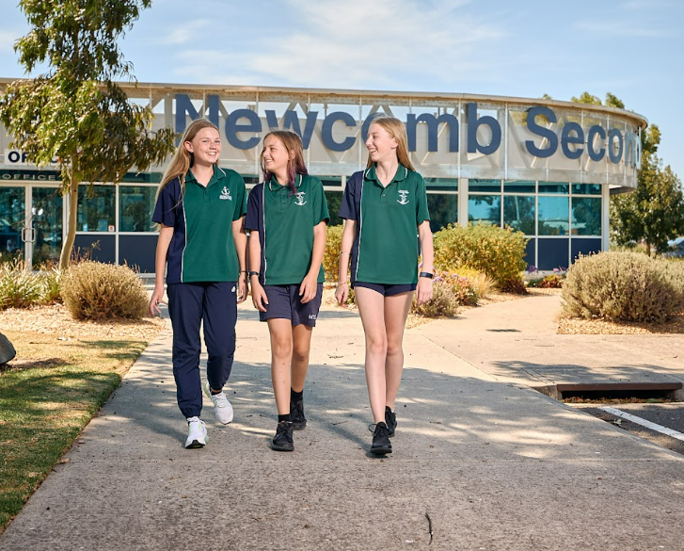

YEAR 7

COURSE OUTLINES

YEAR 7 CURRICULUM

**Overview**

**At Year 7 all students undertake a full course of study that encompasses all Learning Areas.**

**English**

**Humanities**

**Mathematics**

**Science**

**Physical, Health and Sport Education**

**Languages Other Than English (LOTE)**

Indonesian

**The Arts**

Visual Arts

Drama

Music

Instrumental Music (Optional for All Students)

**Getting Ready for the Outside World (GROW)**

**Technology**

Materials & Technology - Food

Materials & Technology – Metal

Year 7 English

**AIMS**

Students learn how the use of language varies according to differences in situations, purposes and audiences. Students study the mechanics of language, including punctuation, sentence structure, organisation of texts, vocabulary and variations in oral presentation.

Students learn techniques and strategies to use in order to read, write, speak and listen more effectively.

**CONTENT/SKILLS**

* **Reading:** Students will be involved in two reading sessions, held weekly in the Learning Resource Centre. For those students who need extra support in reading, they will be tutored in small groups at their reading level. There will be a variety of engaging class activities to develop reading strategies and interest in reading for those students at standard or above. Students will be encouraged to read and respond to a wide range of books of their choice, in small groups with reciprocal teaching of reading strategies to further extend their reading skills. They will read and study a number of novels throughout the year.
* **Writing:** Students will focus on improving their writing skills using the 6 + 1 Traits of Writing strategies. Students will be explicitly taught each of the strategies and will be expected to demonstrate their skills through a range of writing tasks including: Quick writes, Narrative writing, Persuasive writing, Analytical writing, Informative writing, Poetry
* **Speaking:** Students will develop oral language skills through reading aloud from texts, plays, poetry and other material. Participating in group/class discussions; presentations; short talks. There will be an emphasis on language, volume, pace, expression and articulation.
* **Listening:** Students will be helped to develop good listening skills through a variety of classroom activities, involving poetry, plays, stories, music, videos, peers, teachers and guest speakers.

**ASSESSMENT TASKS**

* Narrative
* Persuasive
* Analytical response to text

**COST**

* $18

Year 7 Humanities

 **AIMS**

To introduce students to the basic skills of geography and history, and through this gain an understanding of good citizenship. The units begin to understand the concept of environment, first nations people and their culture as well as examining factors that influence liveability.

**CONTENT/SKILLS**

* First Nations people and culture
* Ancient Civilisations including Greece, Egypt, China and Rome
* Financial Literacy, consumerism and ethics in business.
* Mapping
* Liveability
* Water in the World

**ASSESSMENT TASKS**

* Compare and contrast ancient civilisations.
* Research traditional first nations culture.
* Identifying and applying the B.O.L.T.S.S approach to mapping.
* Research liveability around the world.
* Water Action task

**COST**

* N/A

Year 7 Mathematics

## D:\Users\02577326\AppData\Local\Microsoft\Windows\Temporary Internet Files\Content.IE5\GKG3K8ZT\MP900399539[1].jpgAims

To develop number skills and computational skills. To develop geometric concepts and skills in 2 dimensions and 3 dimensions.

To develop measurement techniques. To develop estimation and approximation. To develop problem solving techniques and strategies. Applying mathematics to everyday situations.

**Content/Skills**

1. Content Strands including Number and Algebra, Measurement and Geometry, Statistics and Probability.
2. Proficiency Strands including Understanding, Fluency, Problem Solving., Reasoning.
3. Students will access Maths Pathways for a fully differentiated learning program.
4. Students will complete Rich tasks designed to complement their learning.
5. Students will use Squizya for additional online homework once per week.

## Assessment TASKS

1. The keeping of an organised workbook.
2. Problem solving exercises.
3. Homework.
4. Projects.
5. Tests.

## COST

1. $65 levy which includes a full subscription to the online program Maths Pathway.

Year 7 Science

**AIMS**

The year 7 curriculum aims to instil a profound appreciation for the natural world as students embark on a journey of discovery through captivating experiments across the domains of chemistry, biology, physics, and earth science.

The safe practices emphasized within the laboratory setting ensure that budding scientists not only explore the wonders of matter, reactions, and energy, but also learn the importance of ethical conduct and accuracy. Guided by the scientific method, students venture into a realm of inquiry where they unravel the mysteries of life, delve into the intricacies of the physical universe, and unearth the dynamic forces shaping our planet.

Through this comprehensive exploration, Year 7 Science empowers students to unveil the profound truths and foster a lifelong passion for scientific inquiry and understanding.

## CONTENT/SKILLS

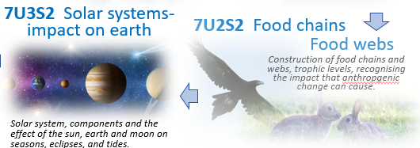

## ASSESSMENT TASKS

* Learning Activities - Participation & completion
* Laboratory activities – Participation & reporting
* Research Task – Independent research and reporting
* Unit test – Written response to multiple choice and short answer questions
* Reflection – Collaborative investigation for further learning

**COST**

* $15
* Covering costs for extra curricula activities and incursions

Year 7 Health and Physical Education

## AIMS

Students will be exposed to a wide variety of activities:skills practices in pairs and small groups, mini games, relays, competitions, tabloids, worksheets, videos, excursions. Classes will rotate through three units each term including Athletics, Football/Soccer, Fitness Netball, Volleyball, Badminton, Cricket, Hockey, Minor games, Basketball, Tee Ball, Lacrosse.

## CONTENT/SKILLS

* To participate in regular physical activity to improve our health and fitness.
* To improve our skills and refine our techniques.
* To understand the game strategies that can help improve our performance.
* To build good relationships with others and improve our teamwork.
* To understand all the changes that are taking place in our lives at this stage.
* To gain knowledge so we make healthy choices.

## ASSESSMENT TASKS

* Show improvement in your skills, game strategies via specific sport peer observations and fitness testing.

**COST**

* N/A

Year 7 LOTE Indonesian

**AIMS**

We will learn about Indonesian language and culture. This insight opens the doors to self-reflection on our own diverse cultures. We will use the Bima text to complete activities, both handwritten an digital. We will be reading, writing, listening and speaking in Indonesian! Topics we focus on include culturally appropriate greetings, life in a tropical country, technology use in Indonesia and food! Using Indonesian to communicate in class will help you gain fluency and proficiency. We will work individually, in pairs and in teams.

**CONTENT/SKILLS**

* Understanding and accepting differences and similarities in cultures around the world.
* Being able to speak and understand another language.
* Understanding the role of grammar in language. This gives us a better understanding of the English language.
* Becoming a mature, responsible individual who can cooperate with others in the classroom to get things done together.

**ASSESSMENT TASKS**

* Topic tests encompassing writing and listening.
* A conversation with your teacher to show off your Indonesian skills
* A rich learning online task using Canva.

**COST**

* N/A

Year 7 The Arts – Visual Arts

**AIMS**

An engaging introduction to elements of two Dimensional Art, three Dimensional Art, Visual Communication and Design and Media. Students will work towards producing a folio of completed artworks in a range of media including Pencil (grey lead and coloured), Acrylic paint, Oil and/or soft pastel, Collage, Clay and plasticine.

**CONTENT/SKILLS**

* Sources of inspiration.
* Designs and options.
* Reasons for your choices and writing about your ideas.
* Development of your folio works.
* Your evaluations of the finished works.
* Documenting processes, skills, key art terms.
* You will investigate the works of artists.
* Units of work including : Portrait, Australian Superhero, Wayang Kulit, Seascape Painting, Papunya

and Western District Artists, Yayoi Kusama Investigation, Ceramics, Facepot.

**ASSESSMENT TASKS**

* Visual Arts Journal.
* Generating and Developing Art Ideas.
* Interpreting and responding to Art.

**COST**

* $35

Year 7 The Arts - Instrumental Music

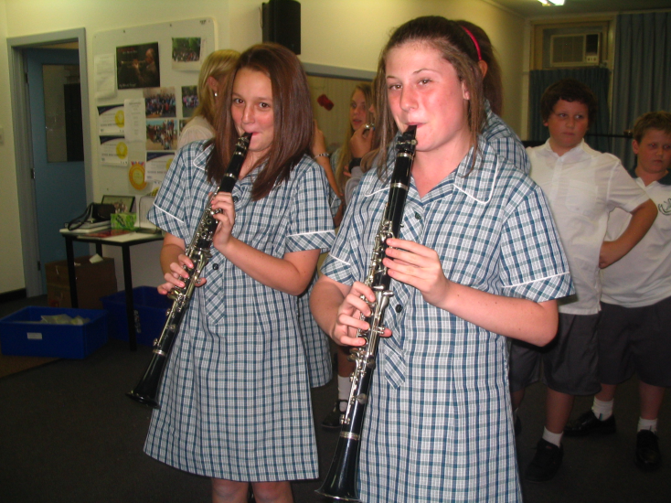

## AIMS

Students to gain skills in playing a musical instrument. To gain knowledge of a wide variety of musical styles. To gain aural perception. To gain an appreciation of music through participation. Participation in the College band program.

**CONCERT BAND PROGRAM (Optional for all students)**

Newcomb Secondary College has three concert bands and two jazz bands. These bands perform at both College and community events throughout the year.

Instrumental music is an integral part of the College music program, providing students with the opportunity to gain skills on concert band instruments. These instruments are clarinet, flute, saxophone, oboe, trumpet, trombone, euphonium, tuba, bass guitar and percussion. Students in this program also participate in the College bands. Participation in this program can lead to VCE Music studies.

## CONTENT/SKILLS

* Arts Practice: Students will undertake a weekly half hour lesson on their instrument, gaining skills in the technique for their instrument, performance technique, aural perception and musical style. Through participation in the band program they will develop performance skills and work with a wide variety of musical styles.

## ASSESSMENT TASKS

N/A

**COST**

* Tuition is provided free of charge. Instrument hire is available from the College for the year.

Year 7 The Arts - Music

**AIMS**

Students develop performance skills using the keyboard, including: finger technique, rehearsal skills, rhythmic skills. Students develop an understanding of basic music theory through note and rest values, time signatures, notation and expressive markings. Students will develop Listening/Aural skills, including: Recognition of different musical instruments and recognition of basic intervals and chords.

**CONTENT/SKILLS**

* Explore and express ideas
  + Develop music language
  + Develop music ideas through composition and performance
* Music practices
  + Create, practice and rehearse music
  + Develop performance skills
  + Structure compositions using notation
  + Develop aural skills
* Present and perform
  + Rehearse and perform music they have learnt and composed
* Respond and interpret
  + Analyse the elements of music when listening to different styles of music

**ASSESSMENT TASKS**:

* A solo keyboard performance of a piece of music chosen by the student.
* Theory worksheets.
* Listening Journal.
* Composition (Garage Band).
* Composition (Pentatonic Melody).

**COST**

* $8

Year 7 Technology - Food

**AIMS**

Students will examine a variety of different food groups and investigate a particular food, its processing and the range of products available. Students will be introduced to the design process and throughout the semester they will design three of their own recipes. These will also be self-evaluated. Students will prepare a variety of meals and baked products utilising a number of skill and techniques. Students will also produce their self-designed meals. Evaluation will be based on the work methods and final product.

**CONTENT/SKILLS**

* To promote a sound knowledge and understanding of particular foods and preparation of them.
* To introduce good nutritional practices.
* To introduce practical cooking skills.
* To encourage independence in class work.
* To develop co-operative group work.

**ASSESSMENT TASKS**

* Design Task: Yummy muffins.
* Design Task: It’s a wrap.
* Design Task: Vegetable Frittata

**COST**

* $50

Year 7 Technology - Metal

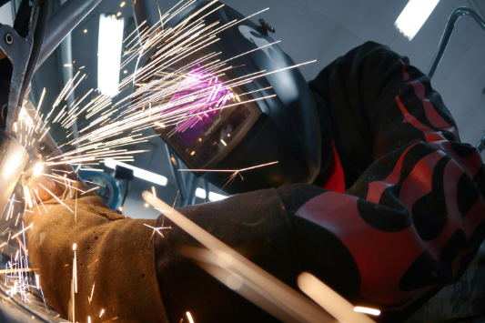**AIMS**

Students participate in a range of learning activities which may include the following: An investigation report presenting information gathered about types of metal. Practical projects to develop skills in tool use and joining and shaping different materials. Design and problem solving activities.

**CONTENT/SKILLS**

* Knowledge of Tools.
* Appropriate Selection of Tools.
* Health and Safety Procedures.
* Processes and Techniques.
* Working in Groups.

Investigating and Designing by:

* Undertaking research.
* Generating ideas by drawing.
* Refining ideas.
* Evaluation.

**ASSESSMENT TASKS**

* Workshop Safety
* Production task
* Digital Design Task

**COST**

* $50

Year 7 GROW

**AIMS**

GROW or ‘Getting Ready for the Outside World’ is a comprehensive and integrated program which develops work skills through our ‘Positive Futures Framework’. With an emphasis on these skills, we embed programs with our P-Tech industry partners, the Geelong Tech School, Deakin University and the Gordon TAFE that seek to provide our students with an holistic education.

**CONTENT/SKILLS**

* Collaboration
* Digital Literacy
* Design Methodology
* Victorian Careers Framework
* Sexual Health & Education

**ASSESSMENT TASKS**

* Design
* Positive Future framework
* Sexual Health & Education
* Robotics
* Capabilities

**COST**

* $20

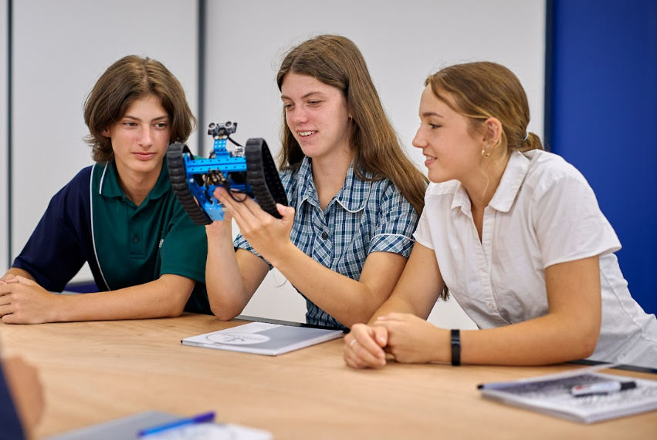

YEAR 8

COURSE OUTLINES

YEAR 8 CURRICULUM

### YEAR 8 CURRICULUM

**OVERVIEW**

**At Year 8 all students undertake a full course of study that encompasses all Learning Areas.**

**English**

**Humanities**

**Mathematics**

**Science**

**Physical, Health and Sport Education**

**Languages Other Than English (LOTE)**

Indonesian

**The Arts**

Visual Arts

Music

Media

Visual Communication & Design

Instrumental Music  (Optional for all Students)

**Getting Ready for the Outside World (GROW)**

**Technology**

Materials & Technology - Fabric

Materials & Technology - Wood

Year 8 English



**AIMS**

All activities take place in the three communication modes: speaking and listening, reading and writing.

Texts studied and produced consist of any communication involving language, including literature, everyday texts, letters and media text.

Students learn how the use of language varies according to different contexts and audiences. Students investigate the purpose of different writing structures.

Students cover the mechanics of language, including punctuation, sentence structure, organization of texts vocabulary and oral presentation.

**CONTENT/SKILLS**

* **Reading:** Students will be involved in a levelled reading program to meet their individual needs. Students will select different texts and engage in reading for a sustained period of time. Students will read and respond to a variety of texts including the assigned novel.Students will increase their understanding of using the Learning Resource Centre, looking at a range of resources available and the development of a bibliography to site work used in assignments.
* **Writing:** Students will participate in a structured writing program focusing on the 6 + 1 Traits of Writing.A writing folio will be completed displaying a range of pieces and styles including: Persuasive Essays, Instructional Writing and a range of Narratives.Students will develop structural skills in writing focussing on correct grammar, sentence structure, paragraph formation, intention and particular audience. Spelling and vocabulary will continue to develop to a comprehensive understanding of two and three syllable high frequency words.
* **Speaking & Listening:** Students will develop their oral language skills by reading aloud from texts, poetry, plays, media and other material. Group discussions, presentations, debates and responses to questions from teachers. Students will formulate oral responses to a range of situations. Emphasis will be placed on expression, fluency, volume, articulation, stance and eye contact when giving formal oral presentations. Students will develop good listening skills through a variety of activities including, plays, stories, music, audio/visual text, peers, teachers and guest speakers.

**ASSESSMENT TASKS**

* Narrative
* Persuasive
* Analytical response to text

**COST**

* $18

Year 8 Humanities

**AIMS**

Through these units, students will investigate landforms including desert and rainforest locations and the impact that mankind has made on these environments. Students will use historical skills to investigate ancient civilizations and the contributions they have made on present day life. Understanding of government structure within Australia. Consideration of First nation’s history, culture and the stolen generation.

**CONTENT/SKILLS**

* Vikings and Polynesia
* Australian Government linked to Civics and Citizenship
* Indigenous Australians
* Natural Disasters
* Landscapes and landforms

**ASSESSMENT TASKS**

* Film analysis and critical and creative thinking linked to topic.
* Research skills including digital resources.
* Presentation skills using various platforms including oral and digital.

**COST**

* N/A

Year 8 Mathematics

*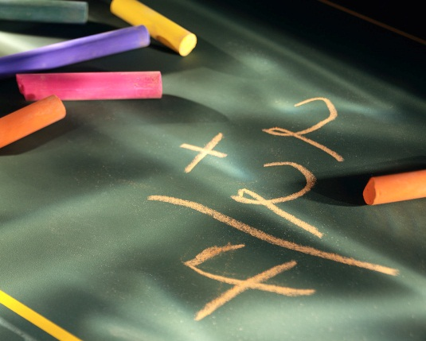***AIMS**

To develop number skills and computational skills. To develop geometric concepts and skills in 2 dimensions and 3 dimensions. To develop measurement techniques. To develop estimation and approximation. To develop reading, interpreting and constructing tables and graphs. To develop problem solving techniques and strategies. To develop applying Mathematics to everyday situations.

**CONTENT/SKILLS**

* Content Strands including Number and Algebra, Measurement and Geometry, Statistics and Probability.
* Proficiency Strands including Understanding, Fluency, Problem Solving, Reasoning.
* Students will access Maths Pathways for a fully differentiated learning program.
* Students will complete Rich tasks designed to complement their learning.
* Students will use Squizya for additional online homework once per week.

**ASSESSMENT TASKS**

* The keeping of an organised workbook.
* Problem solving and investigative tasks.
* Tests.
* Projects.

**COST**

1. $65 levy which includes a full subscription to the online program Maths Pathway.

Year 8 Science

**AIMS**

Year 8 Science ignites a thrilling expedition, while catapulting young minds into an electrifying tapestry of new discovery. Unveiling the mesmerizing biology of cells, students traverse the microscopic landscapes that orchestrate life's symphony, while delving deep into the marvels of body systems, gaining profound insights into the intricate mechanisms propelling us.

The expedition leaps towards Earth's geological wonders, deciphering its chronicles etched in rock. Chemical reactions provide insights into matter and an exploration of physics unravels the ethereal mysteries of sound and light. Amidst this exhilarating odyssey, Year 8 Science stands as a testament: science is the unerring compass leading us to the truth, illuminating our journey through the captivating labyrinth of existence.

**CONTENT/SKILLS**

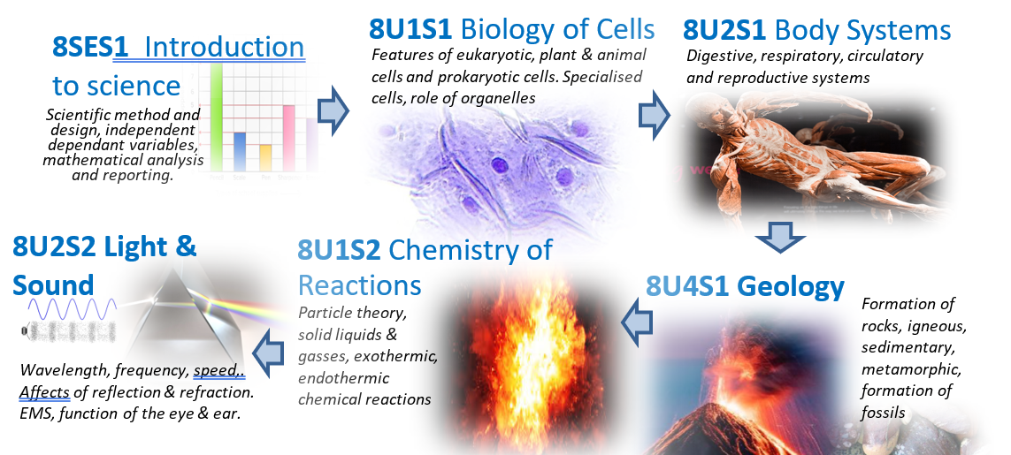

**ASSESSMENT TASKS**

* Learning Activities - Participation & completion
* Laboratory activities – Participation & reporting
* Research Task – Independent research and reporting
* Unit test – Written response to multiple choice and short answer questions
* Reflection – Collaborative investigation for further learning

**COST**

* $15
* Covering costs for extra curricula activities and incursions

Year 8 Health & Physical Education



**AIMS**

Students will be exposed to a wide variety of activities:skills practices in pairs and small groups, mini games, relays, competitions, tabloids, worksheets, videos, excursions. Classes will rotate through three units each term including Athletics, Football/Soccer, Fitness Netball, Volleyball, Badminton, Cricket, Hockey, Minor games, Basketball, Tee Ball, Lacrosse.

## CONTENT/SKILLS

* To participate in regular physical activity to improve our health and fitness.
* To improve our skills and refine our techniques.
* To understand the game strategies that can help improve our performance.
* To build good relationships with others and improve our teamwork.
* To understand all the changes that are taking place in our lives at this stage.
* To gain knowledge so we make healthy choices.

## ASSESSMENT TASKS

* Show improvement in your skills, game strategies via specific sport peer observations and fitness testing.

**COST**

* NA

Year 8 LOTE - Indonesian

**AIMS**

To learn about Indonesian language and culture. This opens the doors to self-reflection on our own diverse cultures. We will use the Bima text to help us complete activities, both handwritten and digital. We will be reading, writing, listening and speaking in Indonesian! Topics include teenage mental health, travelling in a tropical country, the Arts and food! Using Indonesian to communicate in class will help you gain fluency and proficiency. We will work individually, in pairs and in teams to achieve our best in this course.

**CONTENT/SKILLS**

* Understanding and accepting differences and similarities in cultures around the world.
* Being able to speak and understand another language.
* Understanding the role of grammar in language. This gives us a better understanding of the English language.
* Becoming a mature, responsible individual who can cooperate with others in the classroom to get things done together.

**ASSESSMENT TASKS**

* Topic tests encompassing writing and listening.
* A conversation with your Indonesian teacher to show off your Indonesian skills.
* A rich leaning online task using Canva.

**COST**

* N/A

Year 8 Arts Rotations:

**Music – Art** – Media - VCD

**AIMS**

For the Arts in Year 8, students will undertake four single term subjects with a specialist teacher for that subject. Students will have a full term, three periods a week, of the following subjects: Music, Art, Media and Visual Communication and Design (VCD). This 4-term rotation allows students to study each of these areas in depth and enables them to make well informed subject selections for their Arts electives in Years 9 and 10.

**Music**

**CONTENT/SKILLS:**

* Students develop their performance skills using the keyboard. They choose music to work on in class focusing on technique and timing, which they then perform at the end of the term. They also research Indigenous instruments from different countries, looking at how they are played and made and their importance to that particular culture.

**ASSESSMENT TASKS**

* Performance skills - Keyboard
* Musical Instruments from around the World

**COST $10**

**Art**

**CONTENT/SKILLS**

* Students explore a variety of different materials and artforms. They investigate the Pop Art Movement of Art, create a manga character, practise drawing skills, ceramic object, sculpture and a painting.

**ASSESSMENT TASKS**

* Visual Arts Journal: Generate and develop ideas
* Folio of Artworks
* Interpreting and responding to artworks

**COST $30**

Year 8 Arts Rotations:

Music – Art – **Media - VCD**

**AIMS**

For the Arts in Year 8, students will undertake four single term subjects with a specialist teacher for that subject. Students will have a full term, three periods a week, of the following subjects: Music, Art, Media and Visual Communication and Design (VCD). This 4-term rotation allows students to study each of these areas in depth and enables them to make well informed subject selections for their Arts electives in Years 9 and 10.

**Media**

**CONTENT/SKILLS**

* Students learn some basic media language relating to film and television including camera, sound and editing techniques. Students will do a film study and will produce their own short media product in groups.

**ASSESSMENT TASKS**

* Written response to film.
* Creation of a media product.

**COST** $15

**Visual Communication and Design: VCD**

**CONTENT/SKILLS**

* Students apply the design process to develop logo concepts for a Design Brief and then use Photoshop to enhance a scanned drawing and create a final logo. They also learn to use the airbrush and how to draw in the isometric drawing system. Students develop subject specific terminology and respond to the work of professional designers.

**ASSESSMENT TASKS**

* Folio of Design Works.
* Responding to Design Examples.

**COST** $25

Year 8 The Arts - Instrumental Music

## AIMS

Students to gain skills in playing a musical instrument. To gain knowledge of a wide variety of musical styles. To gain aural perception. To gain an appreciation of music through participation. Participation in the College band program.

## CONCERT BAND PROGRAM (Optional for all students)

Instrumental music is an integral part of the College music program, providing students with the opportunity to gain skills on concert band instruments. These instruments are clarinet, flute, saxophone, oboe, trumpet, trombone, euphonium, tuba, bass guitar and percussion. Students in this program also participate in the College bands. Participation in this program can lead to VCE Music studies.

## CONTENT/SKILLS

* Arts Practice: Students will undertake a weekly ½ hour lesson on their instrument, gaining skills in the technique for their instrument, performance technique, aural perception and musical style. Through participation in the band program they will develop performance skills and work with a wide variety of musical styles.

## ASSESSMENT TASKS

**COST**

* Tuition is provided free of charge. Instrument hire is available from the College for the year.

Year 8 Technology – Fabric

**AIMS**

We are going to design and produce a decorative shaped cushion cover for a specific person or purpose. We will screen-print the surface. We will embellish the print with beads, sequins, threads and fabrics. And we will construct the cover using a sewing machine. Our cushions will be closed with buttons, press studs, velcro, ties or a zip. We will look at our work to evaluate it and assess our progress. We will look at the work of each other and commercially produced cushions. We will record our progress throughout the semester in a journal in our workbooks.

**CONTENT/SKILLS**

**Investigating and Designing**

* Designing for a purpose.
* Making appropriate choices.
* Becoming aware of health and safety issues.

**Producing**

* Printing and sewing skills.
* Developing a sense of personal style.
* Learning to think about time management.
* How we can build on the knowledge and skills we are developing.

**Analysing and Evaluating**

* Appreciating handmade, individual pieces.
* Looking at the function, design and quality of similar products.
* Making objective, informed judgements.

**ASSESSMENT TASKS**:

* Designing the cushion.
* Producing the cushion.
* Evaluating the cushion.

**COST**

* $20

Year 8 Technology – Wood

**AIMS**

This unit introduced students to appropriate materials and a range of processes. Students investigated properties of materials, developed simple designs, worked safely in production and evaluated their work.

**CONTENT/SKILLS**

* Knowledge of tools.
* Appropriate selection of tools.
* Health and safety procedures.
* Processes and techniques.
* Working in groups.

Investigating and Designing by:

* Undertaking research.
* Generating ideas by drawing.
* Refining ideas.
* Evaluation.

**ASSESSMENT TASKS**

* Workshop safety
* Design and investigation
* Production tasks including digital manufacturing

**COST**

* $50

Year 8 GROW

**AIMS**

GROW or ‘Getting Ready for the Outside World’ is a comprehensive and integrated program which develops work skills through our ‘Positive Futures Framework’. With an emphasis on these skills, we embed programs with our P-Tech industry partners, the Geelong Tech School, Deakin University and the Gordon TAFE that seek to provide our students with an holistic education. We begin our pathways journey and engage the Victorian Careers Curriculum Framework.

**CONTENT/SKILLS**

* STEM
* Problem Based Learning
* Digital and Design Emphasis
* Sexual Health & Education
* Emerging Technologies

**ASSESSMENT TASKS**

* STEM Engineering Systems
* Victorian Careers Framework Investigation
* Design and Digital Challenges
* Sexual & Health Education

**COST**

* $0